**SQL HWK4**

Download the PV Furniture SQL script from Canvas and create the PVF database.

1. Print out the hardcopy of the Order database instance using SQL statement, for example, Select * from table _name;

Your output should have the full content of the following four tables. You need to copy and paste your SQL statements and their corresponding output to Word file before you print.

SELECT * FROM Order_T;

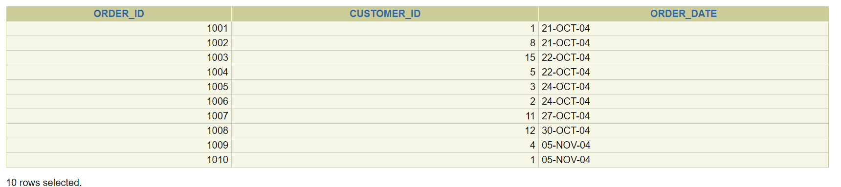

SELECT * FROM Customer_T;

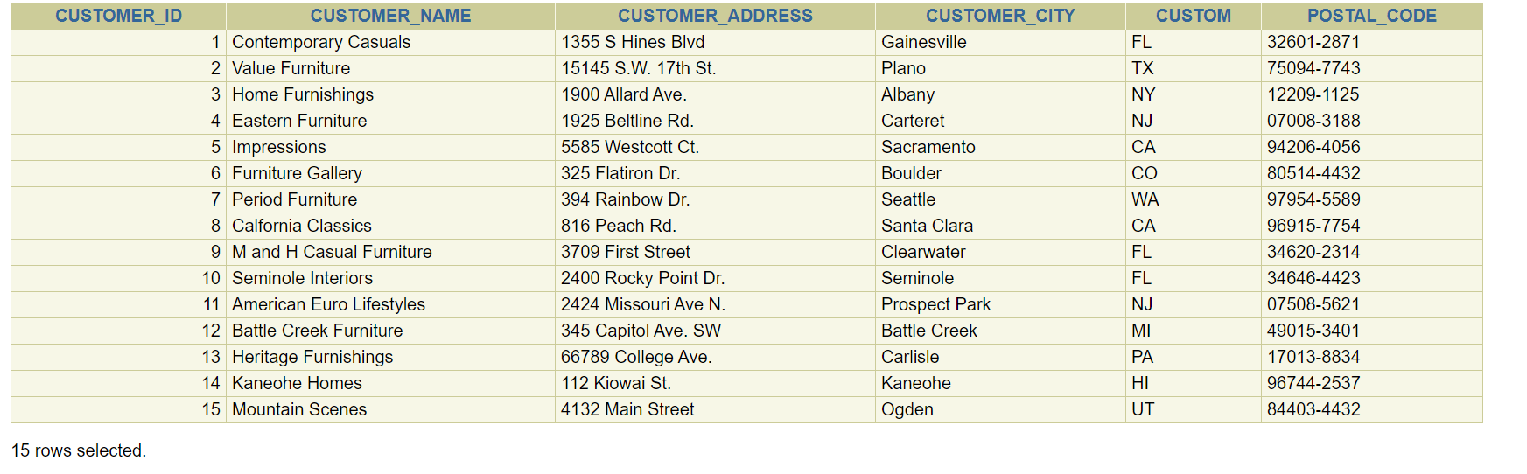

SELECT * FROM Product_T;

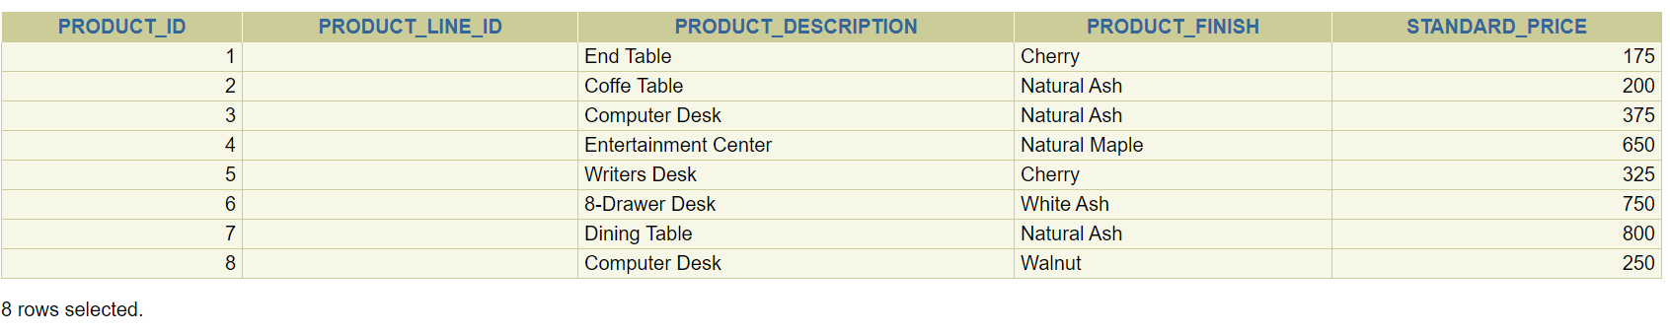

SELECT * FROM OrderLine_T;

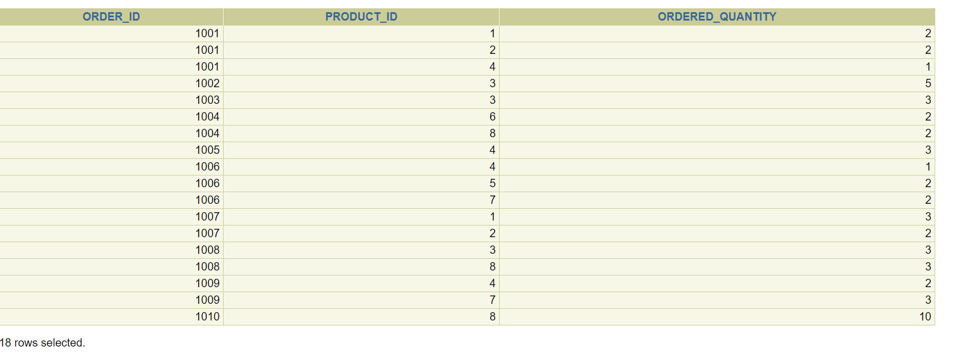

Print out the hardcopy of the database structure using SQLPlus statement, for example, Desc table_name;

Your output should have the structure of the following four tables. You need to copy and paste your SQL statements and their corresponding output to Word file before you print.

Desc table Order_T



Desc table Customer_T

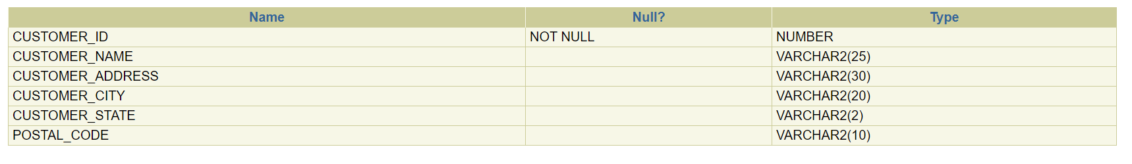

Desc table Product_T

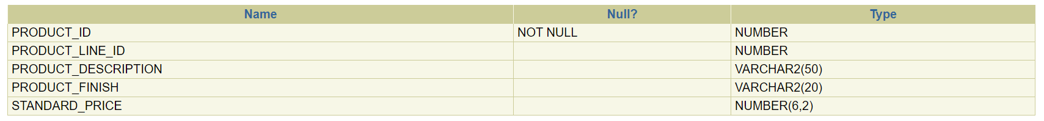

Desc table OrderLine_T



2. Continue working on your Order database on the following queries using SQL statements. Copy and past 1) query question, 2) SQL statement and 3) SQL output to a word file, and print it out.

1. List all the desks in the PVF company that cost between $400 and $500 inclusive.

SELECT product_description, standard_price

FROM product_t

WHERE standard_price BETWEEN 400 and 500

AND product_description LIKE '%Desk';



1. List customer states, cities, names by sorting their state, city and names in ascending order.

SELECT customer_state, customer_city, customer_name

FROM customer_t

ORDER BY customer_state, customer_city, customer_name ASC;

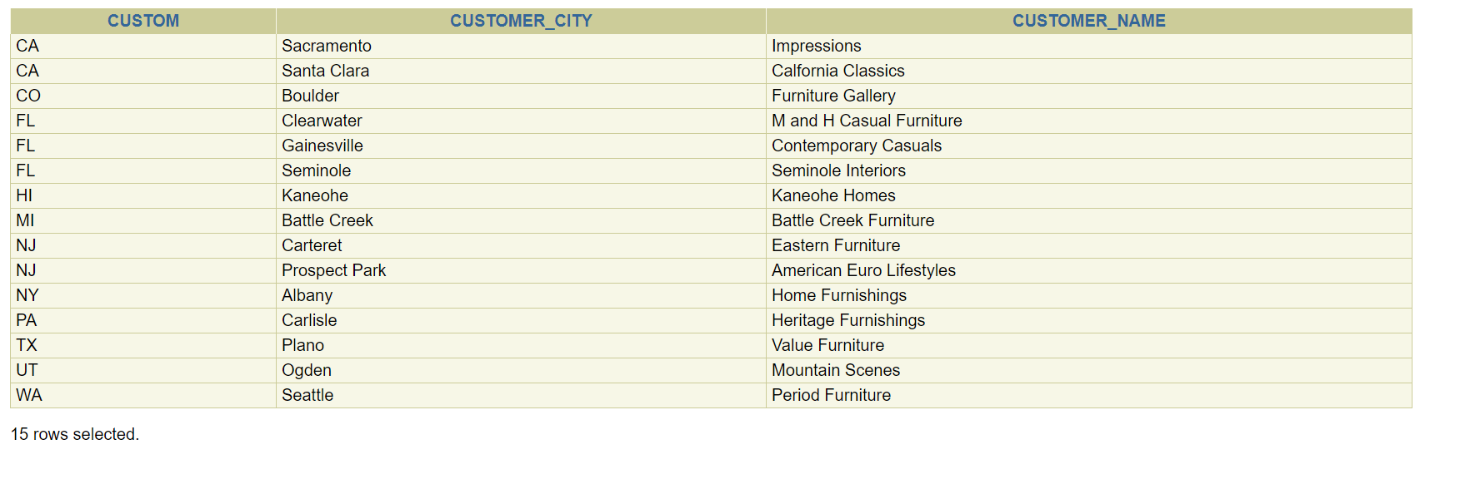

1. Retrieve the names of customers who are in New York and Washington states.

SELECT customer_name, customer_state

FROM customer_t

WHERE customer_state IN ('NY','WA');



1. List the states that have more than 2 customers the PVF company.

SELECT customer_state, COUNT(customer_id)

FROM customer_t

GROUP BY customer_state

HAVING COUNT(customer_id) >2;



1. Display the total cost for each order that has been placed and rename the output columns.

SELECT order_id, SUM(standard_Price * ordered_quantity) AS Total_Cost

FROM product_t, order_line_t

WHERE product_t.product_id = order_line_t.product_id

GROUP BY order_id;

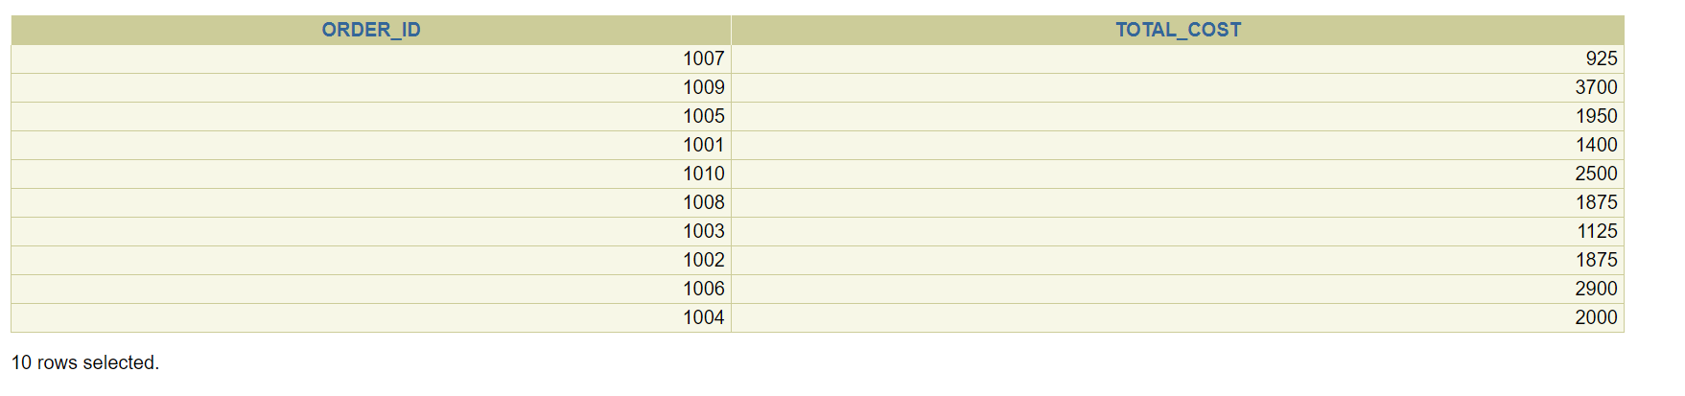

1. Retrieve the average, highest, and lowest price of products in the PVF company.

SELECT AVG(standard_price) as Average_Price, MAX(standard_price) as Highest_Price, MIN(standard_price) as Lowest_Price

FROM product_t;



1. Retrieve the average, highest, and lowest price of each product finish.

SELECT product_finish, AVG(standard_price) as Average_Price, MAX(standard_price) as Highest_Price, MIN(standard_price) as Lowest_Price

FROM product_t

GROUP BY product_finish;

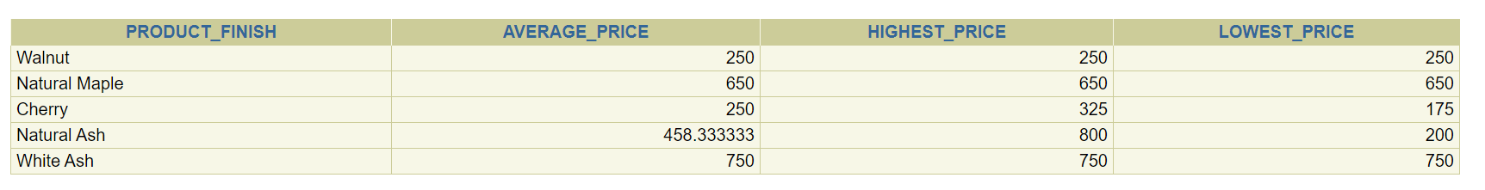

1. Display customer IDs who have made less than 2 orders.

SELECT customer_id, COUNT(order_id)

FROM order_t

GROUP BY customer_id

HAVING COUNT(order_id) < 2 ;

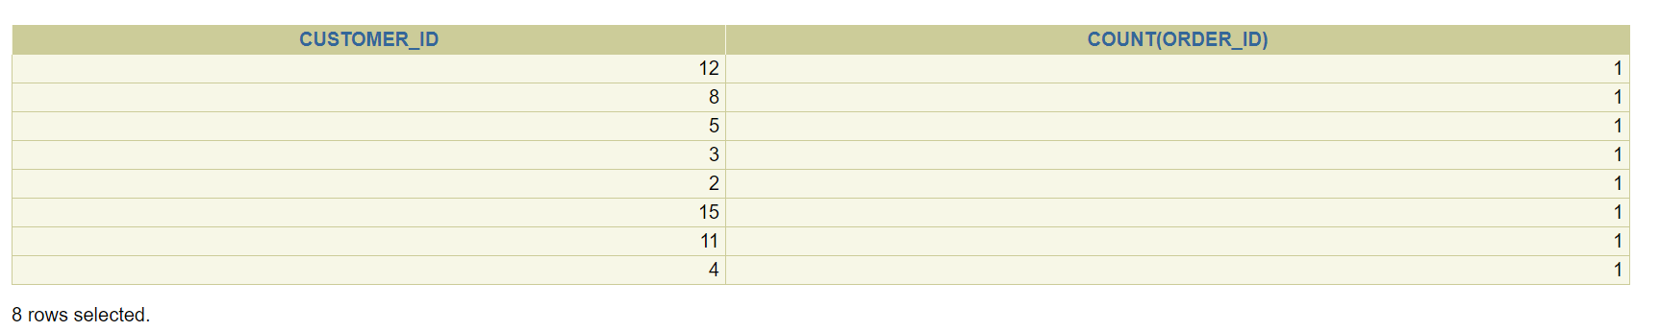

1. Create a view for customer in California and Florida.

CREATE OR REPLACE VIEW CA_FL_Vu

AS SELECT customer_name, customer_state

FROM customer_t

WHERE customer_state IN ('CA', 'FL') ;



SELECT * FROM CA_FL_Vu;

